Name | Shubhan Singh
UID no. | 2022300118
Experiment No. | 1

AIM: | Use the formatted input/output statements, operators and expressions of C language
Program 1
PROBLEM STATEMENT: | Write a C program to input 2 numbers. Perform addition, subtraction, multiplication, division and modulus and display output.
ALGORITHM: | Step 1: START  Step 2: Read two input values A and B  Step 3: Sum = A+B  Step 4: Difference = A-B  Step 5: Product = A*B  Step 6: Division = A/B  Step 7: Modulus = A%B  Step 8: Print Sum, Difference, Product, Division and Modulus.  Step 9: END
FLOWCHART: | 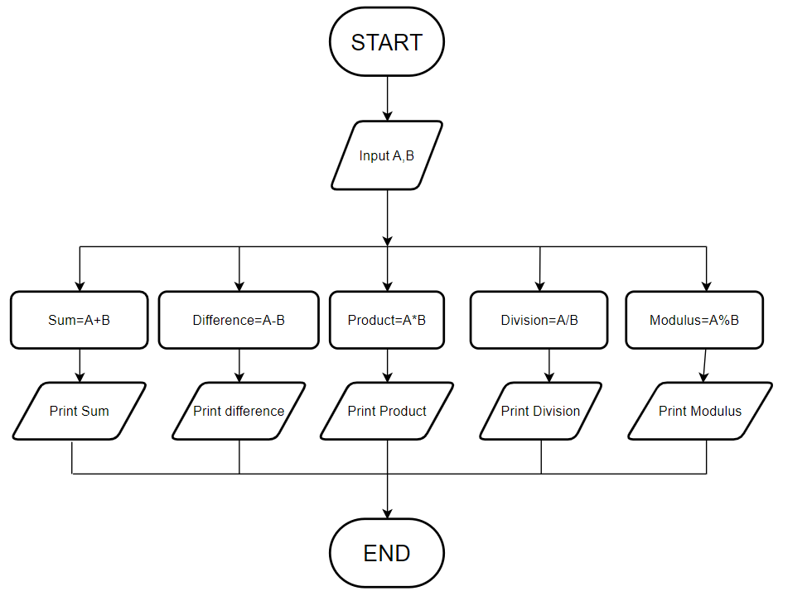
PROGRAM: | #include<stdio.h>  int main(){  int a,b,sum,difference,modulus,product;  float division;  printf("Enter two numbers\n");  scanf("%d %d",&a,&b);  sum=a+b;  difference=a-b;  product=a*b;  division=(float)a/b;  modulus=a%b;  printf("the sum of the two numbers is: %d\n",sum);  printf("the difference between the two numbers is: %d\n",difference);  printf("the product of the two numbers is: %d\n",product);  printf("the division of the two numbers is: %f\n",division);  printf("the modulus of the two numbers is: %d\n",modulus);  return 0;  }
RESULT: 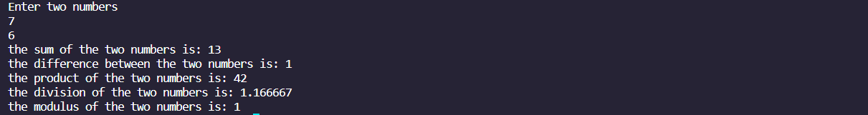
Program 2
PROBLEM STATEMENT : | Write a C program interest.c that calculates the total interest income on amount Rupees 5 lakhs in a period of 10 years. Show the results for simple interest, compounded interest when the compounding is done annually, semi-annually, quarterly, monthly and daily. Assume that the interest rate is 3.5% per year.
ALGORITHM: | Step 1: START  Step 2: Initialize variables with given values  Step 3: Simple interest = a*r*p  Step 4: Compounded interest with annual compounding = a((1+r/100)^p)-1)  Step 5: Compounded interest with semi-annual compounding = a((1+r/200)^2p)-1)  Step 6: Compounded interest with quarterly compounding = a((1+r/400)^4p)-1)  Step 7: Compounded interest with monthly compounding = a((1+r/1200)^12p)-1)  Step 8: Compounded interest with daily compounding = a((1+r/36500)^365p)-1)  Step 9: Print values of all the types of interests calculated  Step 10: END
FLOWCHART: | 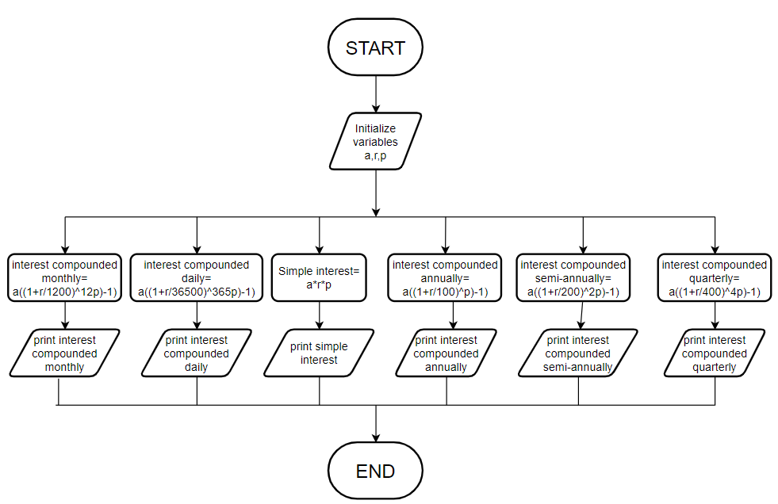
PROGRAM: | #include<stdio.h>  #include<math.h>  int main(){  double a=500000, r=0.035, p=10;  double cia,cisa,ciq,cim,cid;  cia=(a*pow(1+r,1.0*p ))-a;//.0 is for type-casting to double  cisa=(a*pow(1+r/2.0 ,2.0*p))-a;  ciq=(a*pow(1+r/4.0, 4.0*p))-a;  cim=(a*pow(1+r/12.0, 12.0*p))-a;  cid=(a*pow(1+r/365.0, 365.0*p))-a;  printf("\nSimple interest on Rs.500000 in 10 years is %.2lf\n\n", a*r*p);  printf("Interest on Rs.500000 in 10 years compounded annually is %.2lf\n\n", cia);  printf("Interest on Rs.500000 in 10 years compounded semi-annually is %.2lf\n\n", cisa);  printf("Interest on Rs.500000 in 10 years compounded quarterly is %.2lf\n\n", ciq);  printf("Interest on Rs.500000 in 10 years compounded monthly is %.2lf\n\n", cim);  printf("Interest on Rs.500000 in 10 years compounded daily is %.2lf\n\n", cid);  return 0;  }
RESULT: 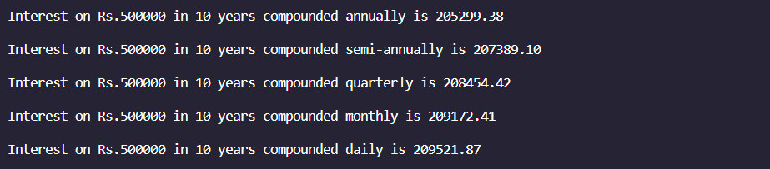
Program 3
PROBLEM STATEMENT: | Write a C program temp.c that accepts a temperature in Fahrenheit and prints the corresponding temperature in Celsius.
ALGORITHM: | Step 1: START  Step 2: Read input value of temperature in degrees Fahrenheit  Step 3: °C = (°F-32)*5/9  Step 4: Print value of temperature in °C  Step 5: END
FLOWCHART: | 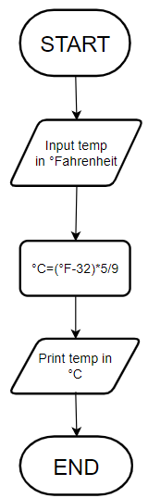
PROGRAM: | #include<stdio.h>  int main()  {  float c,f;  printf("Enter temperature in degrees Fahrenheit: ");  scanf("%f",&f);  c = (f-32)*5/9.0;//.0 for type casting  printf("\n Temp %.2f in Fahrenheit = %.2f Centigrade\n",f,c);  return 0;  }
RESULT: 
Program 4
PROBLEM STATEMENT: | Write a C program to convert days into year, month and days.
ALGORITHM: | Step 1: Read no. of days from input  Step 2: years = days/365 (quotient, not real value)  Step 3: days=days-years*365  Step 4: if 0<=days<31, months=0, days=days  Step 5: else if 31<=days<59, months=1, days=days-31  Step 6: else if 59<=days<90, months=2, days=days-59  Step 7: else if 90<=days<120, months=3, days=days-90  Step 8: else if 120<=days<151, months=4, days=days-120  Step 9: else if 151<=days<181, months=5, days=days-151  Step 10: else if 181<=days<212, months=6, days=days-181  Step 11: else if 212<=days<243, months=7, days=days-212  Step 12: else if 243<=days<273, months=8, days=days-243  Step 13: else if 273<=days<304, months=9, days=days-273  Step 14: else if 304<=days<334, months=10, days=days-304  Step 15: else months=11, days=days-334  Step 16: Print numbers of years, months and days  Step 17: END
FLOWCHART: | 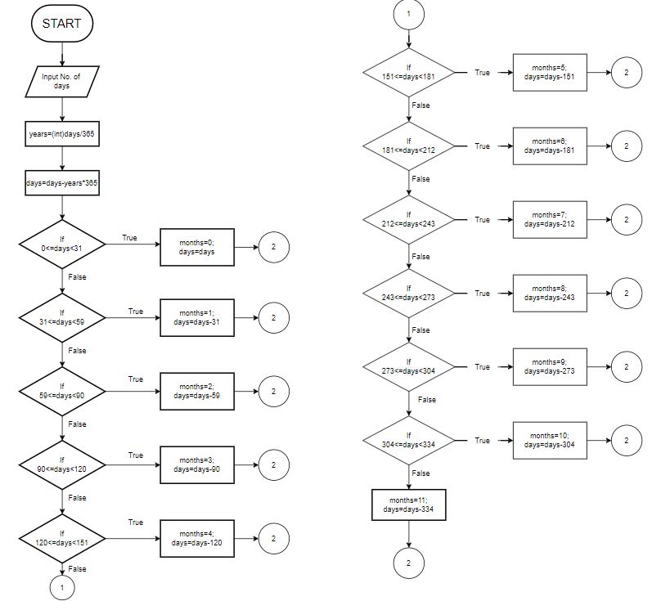  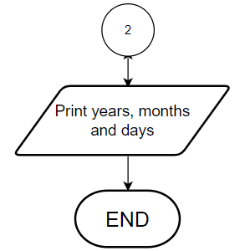
PROGRAM: | #include<stdio.h>  int main(){  int days,months,years,daysfordisplay;  printf("enter number of days\n");  scanf("%d",&days);  daysfordisplay=days;  if(days<0){  printf("invalid input");  return 0;  }  years=days/365;  days=days-(years*365);  if(days>=0 && days<31){months=0;}  else if(days>=31 && days<(31+28)){months=1;days-31;}  else if(days>=(31+28) && days<(31+28+31)){months=2;days=days-31-28;}  else if(days>=(31+28+31) && days<(31+28+31+30)){months=3;days=days-31-28-31;}  else if(days>=(31+28+31+30) && days<(31+28+31+30+31)){months=4;days=days-31-28-31-30;}  else if(days>=(31+28+31+30+31) && days<(31+28+31+30+31+30)){months=5;days=days-31-28-31-30-31;}  else if(days>=(31+28+31+30+31+30) && days<(31+28+31+30+31+30+31)){months=6;days=days-31-28-31-30-31-30;}  else if(days>=(31+28+31+30+31+30+31) && days<(31+28+31+30+31+30+31+31)){months=7;days=days-31-28-31-30-31-30-31;}  else if(days>=(31+28+31+30+31+30+31+31) && days<(31+28+31+30+31+30+31+31+30)){months=8;days=days-31-28-31-30-31-30-31-31;}  else if(days>=(31+28+31+30+31+30+31+31+30) && days<(31+28+31+30+31+30+31+31+30+31)){months=9;days=days-31-28-31-30-31-30-31-31-30;}  else if(days>=(31+28+31+30+31+30+31+31+30+31) && days<(31+28+31+30+31+30+31+31+30+31+30)){months=10;days=days-31-28-31-30-31-30-31-31-30-31;}  else{months=11;days=days-31-28-31-30-31-30-31-31-30-31-30;}  printf("\n%d days are equal to %d years, %d months and %d days", daysfordisplay,years,months,days);  return 0;  }  Screenshot(for readability):  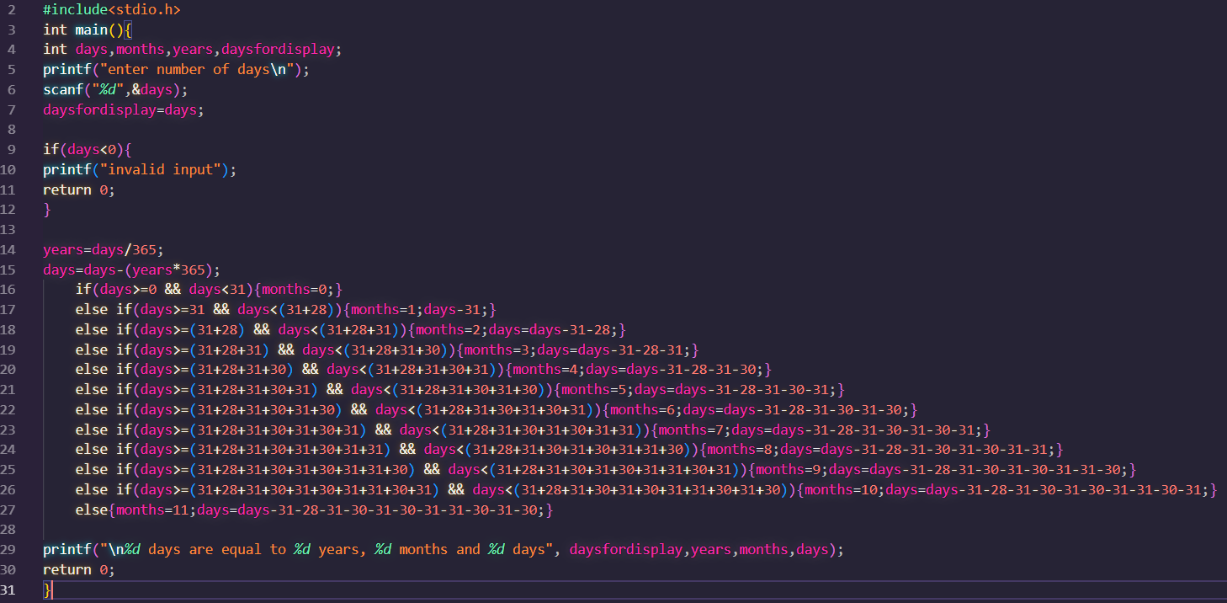
RESULT: 